60-Cup Coffee Urn – User Guide

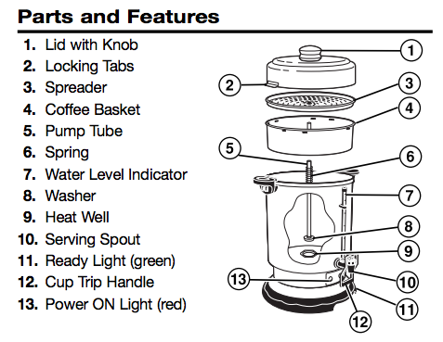

To Make Coffee
- Fill urn with cold tap water to the level indicator mark inside the body for the number of cups desired. This coffee urn makes 20-60 cups of coffee.
- Wet the basket (4) (this helps to keep small particles of coffee grinds from sifting through). Add regular grind coffee to the basket. See chart for the suggested amount of coffee for regular brew.
- Make sure the spring (6) is on the pump tube (5); the place the basket on the pump tube and cover with spreader (3). Then, holding the top of the pump tube, lower it into the coffee urn until the bottom of the pump tube is properly seated in the heat well (9) in the center (if not, the coffee urn may not percolate).
- Place the lid (1), hold the knob and turn the lid clockwise until the locking tabs (2) are fully engaged.
- The red Power ON light (13) will illuminate and coffee brewing will begin within seconds. The urn will begin to percolate within 8 minutes.
- When the brewing cycle is complete, percolation stops and the green READY light illuminates to indicate the coffee is ready to serve. The coffee urn automatically switches to the Keep Warm Cycle. If the brewed coffee is to be kept warm for a long period of time, the basket, spreader, and pump tube should be removed as soon as brewing is complete.

Cofee-Making Chart

Water Level | Amount of Ground Coffee
60 cups (318 oz.) | 3 2/3 – 3 ¾ cups
50 cups (265 oz.) | 3 – 3 ¼ cups
40 cups (212 oz.) | 2 1/3 – 2 ½ cups
30 cups (159 oz.) | 1 ¾ - 2 cups
20 cups (107 oz.) | 1 cup + 1 tbsp – 1 1/3 cups

How To Clean
- Unplug power cord and allow the unit to cool.
- Remove lid and all internal parts.
- Wash the inside of the coffee urn and the parts with warm, soapy water. DO NOT immerse the base of the coffee urn in the water. When washing the pump tube, make sure the washer on the bottom remains loose.

Important Safeguards
- The knob and other parts of the urn will be HOT. Use a pot-holder or oven mitt to remove lid.
- NEVER plug the coffee urn without the lid in place and the locking tabs fully engaged inside the handles.
- Do not place cord, plug, or coffee urn in water or other liquid.
- Unplug from outlet when either the coffee urn is not in use and before cleaning. Allow to cool before putting on or taking off parts and before cleaning the appliance.

